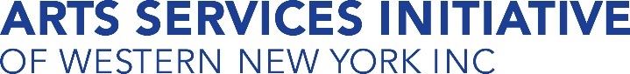
Our Mission and Vision
Contact ASI
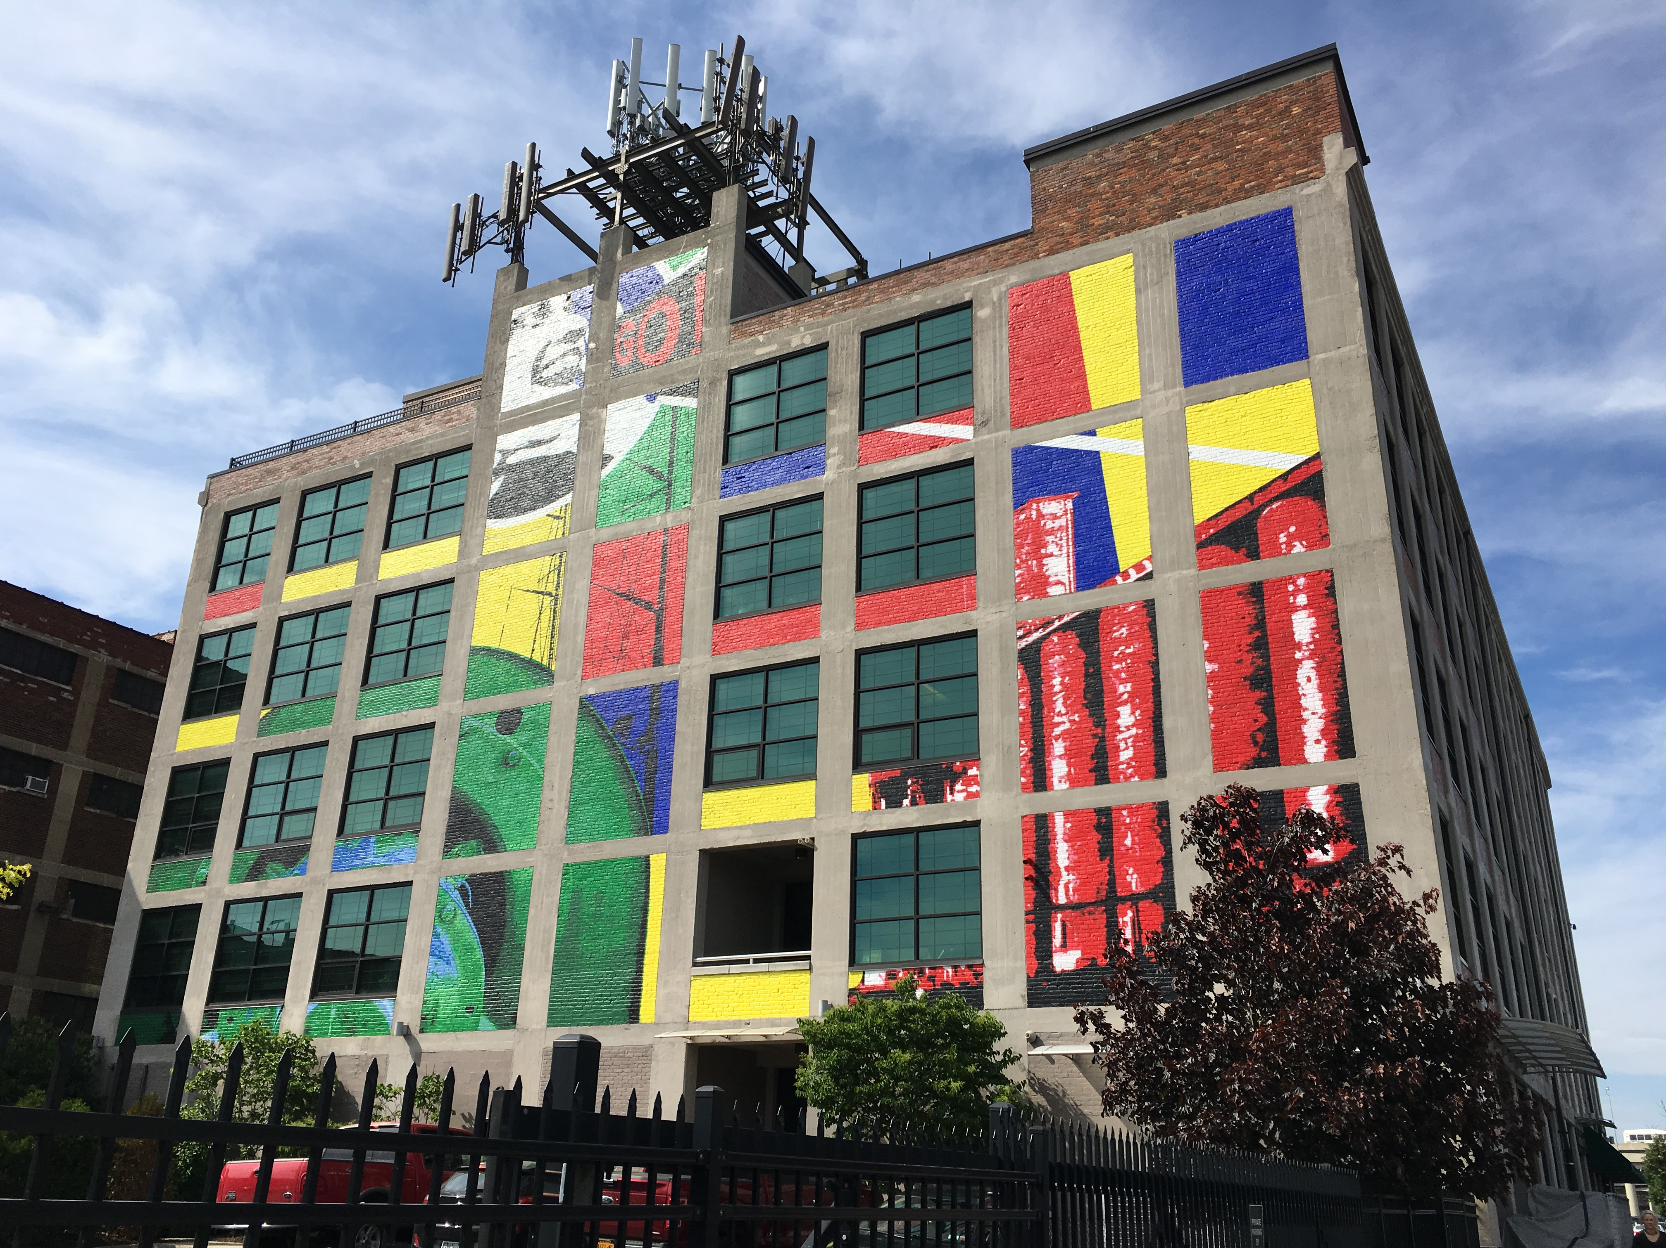
95 Perry St., Suite 402
Buffalo, NY 14202
(716) 362-8389
info@asiwny.org
/asiwny
@asiwny
@asiwny
Thank you to our supporters
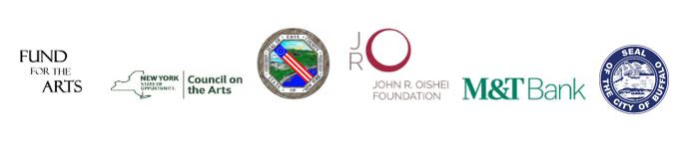

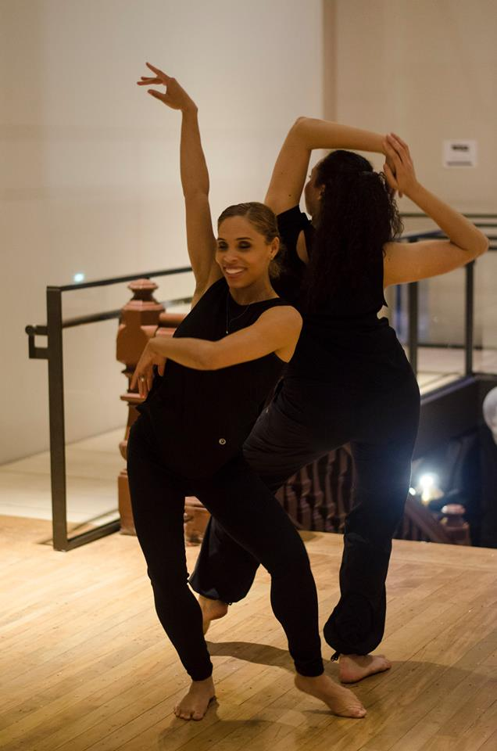
Our mission is to promote the cultural sector's vital role in economic development and the community through advocacy, capacity building, and collaboration. ASI envisions a vibrant community where rich diversity and culture are valued for their countless individual, social, and economic benefits, and where everyone has access to the arts.
Financial Support Services
PROMOTING AND SUPPORTING THE WESTERN NEW YORK CULTURAL SECTOR

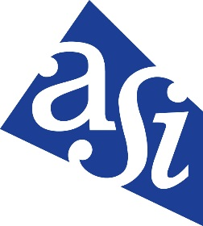
WWW.ASIWNY.ORG
Above: The Carlos Jones Collective at Spark Awards
Front photo: Boomwacker Play-along at Make Music Day
Photos by Ally Spongr
We are ASI!

What’s the First Step?

• The process starts with a consultation (at no charge to you) to identify what your needs are and lay the ground work, structure, and fee for services provided. The services we provide are tailored to each client to fit your financial needs.

• Both of these services also include ASI’s suite of resources including professional development tips and best practices (on topics like budgeting), keeping you up-to-date with rules/regulations/best practices, and other related financial assistance.



For More Information and To Customize Your Financial Services
Contact Mark Banaszak at mark@asiwny.org or
716-362-8389 x513.

Support ASI
Will you help us continue to pursue our mission of supporting, enhancing, and embracing the Western New York arts and cultural community?
I choose to support (please select one) …
____ All of ASI’s work
Or select a specific program:
____ Arts Access
Increasing accessibility to the arts for low-income WNY residents through the Arts Access pass.
____ Give for Greatness
Small scale grants for WNY arts and cultural organizations.
____ Professional Development
Free year-round workshops for artists and cultural organizations.
____ Make Music Day
A one-day celebration of music in Erie and Niagara County.
Checks can be made payable to ASI. Please detach this slip and send with payment to 95 Perry, Suite 402 Buffalo NY 14203.
Thank you for supporting ASI!
Arts Services Initiative of Western New York (ASI) offers financial support services for organizations and artists. We offer two services:
Bookkeeping Services
• Intended for non-profit organizations or for-profit businesses in arts and culture that need “regular, on-going basis” financial assistance.
• Organize your financial records and assist with budgeting needs.
• Donation processing services for campaigns and events.
Fiscal Sponsorship Service
• Fiscal sponsorship is a fundraising tool that enables an individual, group of individuals, or organization to raise funds using some of the benefits of a 501(c)(3) organization.
• We also provide this service for artists wanting to apply to the New York State Council on the Arts (NYSCA) annual grant application process.

