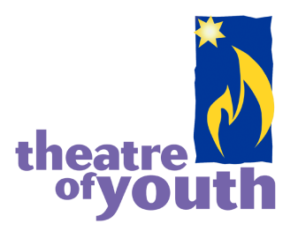

The Theatre of Youth Company, Inc. (TOY) seeks a Managing Director to provide operations and fiscal oversight to this non-profit professional theatre company. Located in Buffalo, New York, TOY is dedicated to the enhancement of life in the community through the enrichment, education, and entertainment of young audiences. TOY is currently the largest resident producing children’s theatre company in New York State.

Rich in arts, culture and entertainment, Western New York is home to more than 20 professional theatre companies. TOY, along with a diverse array of other companies, is integral to the quality of life enjoyed by residents throughout the area. Four beautiful seasons, unique locally owned restaurants, historic architecture, state of the art medical expertise and reputable educational institutions are only a few highlights of WNY. The region continues to experience a growing and increasingly vibrant regional economy.

Under the direction of the Board of Directors, the Managing Director is responsible for the overall management and operations of the Theatre of Youth Company, Inc. and protection of the organization’s financial assets. He/she will ensure compliance with board directives and applicable grantor, federal and state requirements. The Managing Director reports to the Board of Directors and works in collaboration with the Artistic Director.

**Role and Responsibilities**

* Implement policies set by the Board of Directors, meet specific quarterly and annual goals/objectives jointly established with the Executive Committee, and manage the financial, program and administration for the organization.
* Coordination of long-range and annual planning in collaboration with the Artistic Director and the Board of Directors.
* Develop annual budget in conjunction with the Artistic Director; develop monthly financial reporting and forecasting, cash flow management, capital spending and expenditures review and approval.
* Lead and actively participate in sales, fundraising activities, donor development, grant seeking, and grant reporting.
* Act as the representative, spokesperson, and advocate of the theatre along with the Artistic Director with government agencies, media organizations, community and local business groups and arts organizations.
* Administer and support all educational programs of the theatre in collaboration with the Artistic Director and Education Director.
* Manage the operation and maintenance of the theatre.
* Supervise the administrative staff and direct administrative operations.

**Qualifications and Education Requirements**

* An undergraduate degree is required along with 5 years of experience in a non-profit arts management/leadership position, with demonstrated experience in fundraising, grant writing and marketing. Two years Managing Director experience position preferred.
* Strong budgeting and financial management skills.
* Demonstrate and drive a collaborative leadership style/environment.
* Ability to lead, manage, motivate and inspire the administrative team.
* Exhibit excellent interpersonal and communication (both written and verbal) skills.
* Demonstrate a strong work ethic and deep passion for children’s theatre and the mission of TOY.

Interested candidates should send resume & cover letter to [careers@theatreofyouth.org](mailto:careers@theatreofyouth.org)

Find us on Facebook [www.facebook.com/TheatreofYouth](http://www.facebook.com/TheatreofYouth)